231-889-4429 5471 Fairview Street, Box 119 Onekama, MI

TRINITY LUTHERAN CHURCH
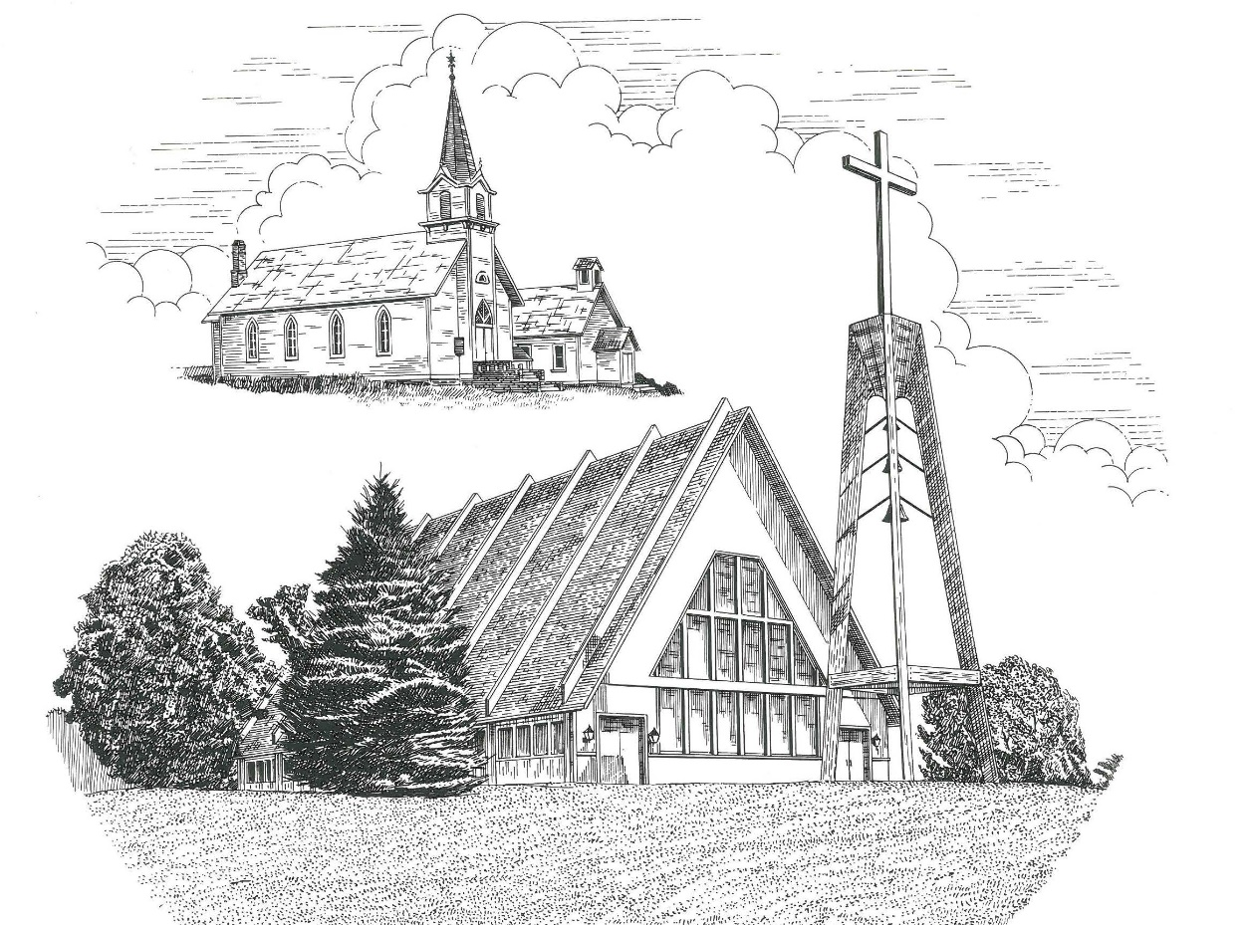

Eighteenth Sunday after Pentecost October 9th, 2022

WELCOME
Thanks for joining us!
Pastor Jacob Sherry Missouri Synod

~~PLEASE NOTE~~
Calling on the name of the Lord
Does not include the use of cell phones in the worship sanctuary.
Please check yours before the service begins. Thank you for your courtesy.
~~TO OUR GUESTS AND VISITORS~~
Please sign our guest book located on the stand at the church entrance. During the service, we ask you to sign the attendance sheet located in your bulletin and place it on the pew when you leave. If you need assistance or have questions about our worship service, please talk to an elder or any one of our church family. We are glad you could join us and hope to have you worship with us again soon.

~~ATTENDING HOLY COMMUNION~~
By checking the “Communing Today” box on the registration form found on the attendance sheet, you are agreeing with the following statements:

- I am a baptized Christian who believes Jesus Christ is my Lord and Savior.
- I believe that I am a sinner in need of Christ freely offered forgiveness.
- I believe that in the Lord’s Supper the body and blood of Jesus Christ
are truly present in, with, and under the bread and wine.
- I believe that my participation in Holy Communion grants me forgiveness
of my sins, new spiritual life, and eternal salvation.
- With God’s help, I sincerely seek to repent of my sins, live in service
to my Lord, and await His return.

If you agree with the above statements, you are welcome to attend the Lord’s Supper with us. May God bless your worship time with us.
We do offer gluten-free wafers, please quietly ask an elder to help you.

Order of Divine Service Setting Three

Pre-Service Music……………..Call to Worship………………….Greeting

OPENING HYMN: “This Is the Day the Lord Has Made”.....................LSB #903
OPENING LITURGY:
Confession & Absolution………..………………………………LSB pp. 184-185
Kyrie…………………………………….………………………..LSB p. 186
Gloria in Excelsis………………………………………………...LSB pp. 187-189
Salutation….……………………………….…………………….LSB p. 189

Collect Prayer
Almighty God, You show mercy to Your people in all their troubles. Grant us always to recognize Your goodness, give thanks for Your compassion, and praise Your holy name; through Jesus Christ, Your Son, our Lord, who lives and reigns with You and the Holy Spirit, one God, now and forever.

THE HOLY SCRIPTURES

OLD TESTAMENT: (Ruth 1:1-19a)
In the days when the judges ruled there was a famine in the land, and a man of Bethlehem in Judah went to sojourn in the country of Moab, he and his wife and his two sons. ² The name of the man was Elimelech and the name of his wife Naomi, and the names of his two sons were Mahlon and Chilion. They were Ephrathites from Bethlehem in Judah. They went into the country of Moab and remained there. ³ But Elimelech, the husband of Naomi, died, and she was left with her two sons. ⁴ These took Moabite wives; the name of the one was Orpah and the name of the other Ruth. They lived there about ten years, ⁵ and both Mahlon and Chilion died, so that the woman was left without her two sons and her husband.
⁶ Then Naomi arose with her daughters-in-law to return from the country of Moab, for she had heard in the fields of Moab that the Lord had visited his people and given them food. ⁷ So she set out from the place where she was with her two daughters-in-law, and they went on the way to return to the land of Judah. ⁸ But Naomi said to her two daughters-in-law, “Go, return each of you to her mother's house. May the Lord deal kindly with you, as you have dealt with the dead and with me. ⁹ The Lord grant that you may find rest, each of you in the house of her husband!” Then she kissed them, and they lifted up their voices and wept. ¹⁰ And they said to her, “No, we will return with you to your people.” ¹¹ But Naomi said, “Turn back, my daughters; why will you go with me? Have I yet sons in my womb that they may become your husbands? ¹² Turn back, my daughters; go your way, for I am too old to have a husband. If I should say I have hope, even if I should have a husband this night and should bear sons, ¹³ would you therefore wait till they were grown? Would you therefore refrain from marrying? No, my daughters, for it is exceedingly bitter to me for your sake that the hand of the Lord has gone out against me.” ¹⁴ Then they lifted up their voices and wept again. And Orpah kissed her mother-in-law, but Ruth clung to her.
¹⁵ And she said, “See, your sister-in-law has gone back to her people and to her gods; return after your sister-in-law.” ¹⁶ But Ruth said, “Do not urge me to leave you or to return from following you. For where you go I will go, and where you lodge I will lodge. Your people shall be my people, and your God my God. ¹⁷ Where you die I will die, and there will I be buried. May the Lord do so to me and more also if anything but death parts me from you.” ¹⁸ And when Naomi saw that she was determined to go with her, she said no more. ¹⁹ So the two of them went on until they came to Bethlehem. And when they came to Bethlehem, the whole town was stirred because of them. And the women said, “Is this Naomi?”

R: This is the Word of the Lord. Cong: Thanks be to God.

GRADUAL
Reader: He will command his angels concerning you
Cong.: to guard you in all your ways.
Reader: Bless the Lord, O my soul,
Cong.: and all that is within me, bless his holy name!

EPISTLE: (2 Timothy 2:1-13)
“You then, my child, be strengthened by the grace that is in Christ Jesus, ² and what you have heard from me in the presence of many witnesses entrust to faithful men, who will be able to teach others also. ³ Share in suffering as a good soldier of Christ Jesus. ⁴ No soldier gets entangled in civilian pursuits, since his aim is to please the one who enlisted him. ⁵ An athlete is not crowned unless he competes according to the rules. ⁶ It is the hard-working farmer who ought to have the first share of the crops. ⁷ Think over what I say, for the Lord will give you understanding in everything.
⁸ Remember Jesus Christ, risen from the dead, the offspring of David, as preached in my gospel, ⁹ for which I am suffering, bound with chains as a criminal. But the word of God is not bound! ¹⁰ Therefore I endure everything for the sake of the elect, that they also may obtain the salvation that is in Christ Jesus with eternal glory. ¹¹ The saying is trustworthy, for:
If we have died with him, we will also live with him;
¹² if we endure, we will also reign with him;
if we deny him, he also will deny us;
¹³ if we are faithless, he remains faithful—
for he cannot deny himself.

R: This is the Word of the Lord. Cong: Thanks be to God.

(PLEASE RISE for the reading of the Gospel)

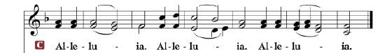

R: The Holy Gospel according to St. Luke, the 23rd chapter.

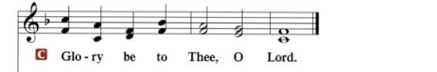

HOLY GOSPEL: (Luke 23:26, 32-46)
²⁶ And as they led him away, they seized one Simon of Cyrene, who was coming in from the country, and laid on him the cross, to carry it behind Jesus.
³² Two others, who were criminals, were led away to be put to death with him. ³³ And when they came to the place that is called The Skull, there they crucified him, and the criminals, one on his right and one on his left. ³⁴ And Jesus said, “Father, forgive them, for they know not what they do.” And they cast lots to divide his garments. ³⁵ And the people stood by, watching, but the rulers scoffed at him, saying, “He saved others; let him save himself, if he is the Christ of God, his Chosen One!” ³⁶ The soldiers also mocked him, coming up and offering him sour wine ³⁷ and saying, “If you are the King of the Jews, save yourself!” ³⁸ There was also an inscription over him, “This is the King of the Jews.”
³⁹ One of the criminals who were hanged railed at him, saying, “Are you not the Christ? Save yourself and us!” ⁴⁰ But the other rebuked him, saying, “Do you not fear God, since you are under the same sentence of condemnation? ⁴¹ And we indeed justly, for we are receiving the due reward of our deeds; but this man has done nothing wrong.” ⁴² And he said, “Jesus, remember me when you come into your kingdom.” ⁴³ And he said to him, “Truly, I say to you, today you will be with me in paradise.”
⁴⁴ It was now about the sixth hour, and there was darkness over the whole land until the ninth hour, ⁴⁵ while the sun's light failed. And the curtain of the temple was torn in two. ⁴⁶ Then Jesus, calling out with a loud voice, said, “Father, into your hands I commit my spirit!” And having said this he breathed his last.

R: This is the Gospel of the Lord.

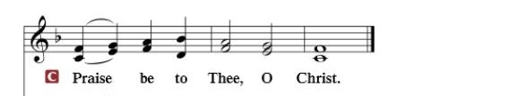

Nicene Creed
I believe in one God, the Father Almighty, maker of heaven and earth and of all things visible and invisible.
And in one Lord Jesus Christ, the only-begotten Son of God, begotten of His Father before all worlds, God of God, Light of Light, very God of very God, begotten, not made, being of one substance with the Father, by whom all things were made; who for us men and for our salvation came down from heaven and was incarnate by the Holy Spirit of the virgin Mary and was made man; and was crucified also for us under Pontius Pilate. He suffered and was buried. And the third day He rose again according to the Scriptures and ascended into heaven and sits at the right hand of the Father. And He will come again with glory to judge both the living and the dead, whose kingdom will have no end.
And I believe in the Holy Spirit, the Lord and giver of life, who proceeds from the Father and the Son, who with the Father and the Son together is worshiped and glorified, who spoke by the prophets. And I believe in one holy Christian and apostolic Church, I acknowledge one Baptism for the remission of sins, and I look for the resurrection of the dead and the life of the world to come. Amen.
SERMON HYMN: “Stricken, Smitten, and Afflicted”……….................LSB #451

SERMON

OFFERTORY…………………………………………………………...LSB pp. 192-193

GENERAL PRAYERS OF THE CHURCH

Sharing the Peace of the Lord

SERVICE OF THE SACRAMENT
Preface…………………………………….…………….……….LSB p. 194
Proper Preface
It is truly good, right, and salutary that we should at all times and in all places give thanks to You, holy Lord, almighty Father, everlasting God, through Jesus Christ, our Lord, who, out of love for His fallen creation, humbled Himself by taking on the form of a servant, becoming obedient unto death, even death upon a cross. Risen from the dead, He has freed us from eternal death and given us life everlasting. Therefore, with angels and archangels and with all the company of heaven we laud and magnify Your glorious name, ever more praising You and saying:

Sanctus, Lord’s Prayer, The Words of Our Lord………………….....LSB pp. 195-197
Agnus Dei………………………………………………………………..LSB p. 198
If you are not communing, it is acceptable to remain seated.

COMMUNION DISTRIBUTION HYMNS:
LSB #606 “I Lay My Sins on Jesus”
LSB #664 “Fight the Good Fight”
LSB #637 “Draw Near and Take the Body of the Lord”

NUNC DIMITTIS………………………………………………………LSB pp. 199-200

BENEDICTION

CLOSING HYMN: “Praise the Almighty”.............................................LSB #797

The Mission of Trinity Onekama Is To SERVE

For even the Son of Man did not come to be served
but to serve and to give his life as a ransom for many.
Mark 10:45

S haring Jesus’s truth
E quipping for life
R eaching Out
V aluing each other
E vangelizing all ages
Mission Statement
The mission of Trinity Onekama is to SERVE
For even the Son of Man did not come to be served, but to serve,
and to give his life as a ransom for many. Mark 10:45
S haring Jesus’ ruth
E quipping for life
R eaching Out
V aluing each other
E vangelizing all age

CHURCH INFORMATION
Church Office: (231) 889-4429 Website: www.trinityonekama.org
E-mail: trinityonekama@sbcglobal.net
Address: P.O. Box 119, 5471 Fairview Street, Onekama, MI 49675
Adult Bible Study: Sunday @ 11:30 am (year round)
Worship: Sunday @ 10:30 am The Lord’s Supper: Celebrated 2nd & 4th Sundays
Pastoral Hours: Wednesday and Friday 9:00am – Noon
Pastor Phone: 231-655-2680 Pastor Email: trinityonekama@gmail.com

Copyright licensing covered under CCLI #2802932

