231-889-4429 5471 Fairview Street, Box 119 Onekama, MI

TRINITY LUTHERAN CHURCH
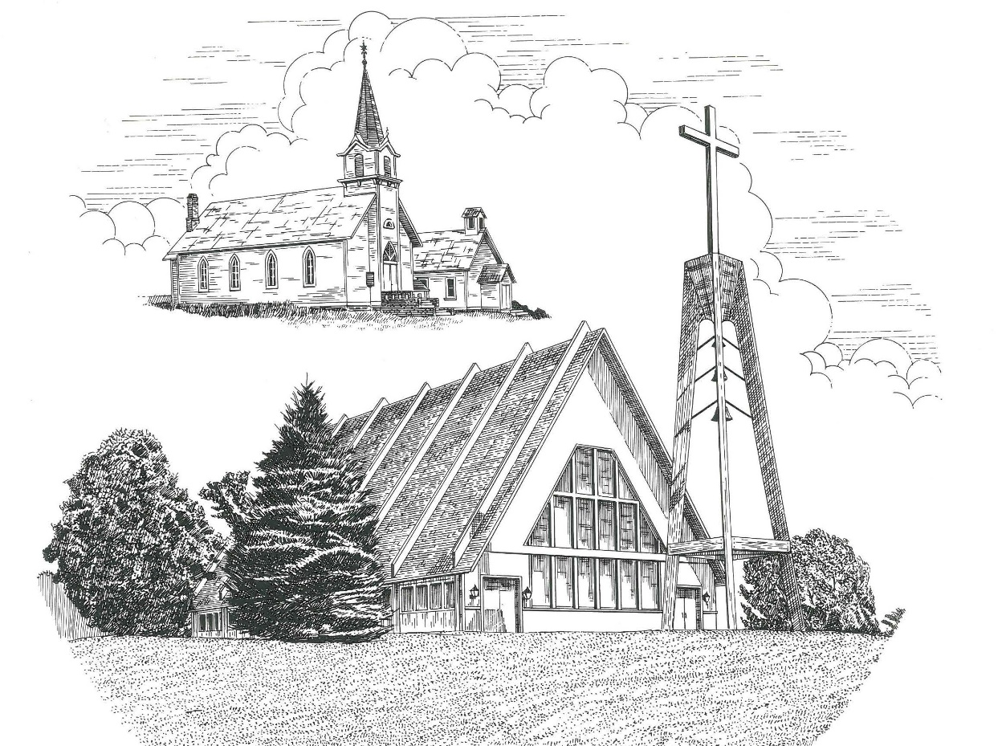

Fourteenth Sunday after Pentecost September 11th, 2022

WELCOME
Thanks for joining us!
Pastor Jacob Sherry Missouri Synod

~~PLEASE NOTE~~
Calling on the name of the Lord
Does not include the use of cell phones in the worship sanctuary.
Please check yours before the service begins. Thank you for your courtesy.
~~TO OUR GUESTS AND VISITORS~~
Please sign our guest book located on the stand at the church entrance. During the service, we ask you to sign the attendance sheet located in your bulletin and place it on the pew when you leave. If you need assistance or have questions about our worship service, please talk to an elder or any one of our church family. We are glad you could join us and hope to have you worship with us again soon.

~~ATTENDING HOLY COMMUNION~~
By checking the “Communing Today” box on the registration form found on the attendance sheet, you are agreeing with the following statements:

- I am a baptized Christian who believes Jesus Christ is my Lord and Savior.
- I believe that I am a sinner in need of Christ freely offered forgiveness.
- I believe that in the Lord’s Supper the body and blood of Jesus Christ
are truly present in, with, and under the bread and wine.
- I believe that my participation in Holy Communion grants me forgiveness
of my sins, new spiritual life, and eternal salvation.
- With God’s help, I sincerely seek to repent of my sins, live in service
to my Lord, and await His return.

If you agree with the above statements, you are welcome to attend the Lord’s Supper with us. May God bless your worship time with us.
We do offer gluten-free wafers, please quietly ask an elder to help you.

Order of Divine Service Setting Three

Pre-Service Music……………..Call to Worship………………….Greeting

OPENING HYMN: “Lord Jesus Christ, Be Present Now”.....................LSB #902
OPENING LITURGY:
Confession & Absolution………..………………………………LSB pp. 184-185
Kyrie…………………………………….………………………..LSB p. 186
Gloria in Excelsis………………………………………………...LSB pp. 187-189
Salutation….……………………………….…………………….LSB p. 189

Collect Prayer
Lord Jesus, You are the Good Shepherd, without whom nothing is secure. Rescue and preserve us that we may not be lost forever but follow You, rejoicing in the way that leads to eternal life; for You live and reign with the Father and the Holy Spirit, one God, now and forever.

THE HOLY SCRIPTURES

OLD TESTAMENT: (Ezekiel 34:11-24)
¹¹ “For thus says the Lord God: Behold, I, I myself will search for my sheep and will seek them out. ¹² As a shepherd seeks out his flock when he is among his sheep that have been scattered, so will I seek out my sheep, and I will rescue them from all places where they have been scattered on a day of clouds and thick darkness. ¹³ And I will bring them out from the peoples and gather them from the countries, and will bring them into their own land. And I will feed them on the mountains of Israel, by the ravines, and in all the inhabited places of the country. ¹⁴ I will feed them with good pasture, and on the mountain heights of Israel shall be their grazing land. There they shall lie down in good grazing land, and on rich pasture they shall feed on the mountains of Israel. ¹⁵ I myself will be the shepherd of my sheep, and I myself will make them lie down, declares the Lord God. ¹⁶ I will seek the lost, and I will bring back the strayed, and I will bind up the injured, and I will strengthen the weak, and the fat and the strong I will destroy. I will feed them in justice.
¹⁷ “As for you, my flock, thus says the Lord God: Behold, I judge between sheep and sheep, between rams and male goats. ¹⁸ Is it not enough for you to feed on the good pasture, that you must tread down with your feet the rest of your pasture; and to drink of clear water, that you must muddy the rest of the water with your feet? ¹⁹ And must my sheep eat what you have trodden with your feet, and drink what you have muddied with your feet? ²⁰ “Therefore, thus says the Lord God to them: Behold, I, I myself will judge between the fat sheep and the lean sheep. ²¹ Because you push with side and shoulder, and thrust at all the weak with your horns, till you have scattered them abroad, ²² I will rescue my flock; they shall no longer be a prey. And I will judge between sheep and sheep. ²³ And I will set up over them one shepherd, my servant David, and he shall feed them: he shall feed them and be their shepherd. ²⁴ And I, the Lord, will be their God, and my servant David shall be prince among them. I am the Lord; I have spoken.

R: This is the Word of the Lord. Cong: Thanks be to God.

GRADUAL
Reader: Fear the Lord, you his saints,
Cong.: for those who fear him lack nothing!
Reader: Many are the afflictions of the righteous,
Cong.: but the Lord delivers him out of them all.

EPISTLE: (1 Timothy 1:12-17)
¹² I thank him who has given me strength, Christ Jesus our Lord, because he judged me faithful, appointing me to his service, ¹³ though formerly I was a blasphemer, persecutor, and insolent opponent. But I received mercy because I had acted ignorantly in unbelief, ¹⁴ and the grace of our Lord overflowed for me with the faith and love that are in Christ Jesus. ¹⁵ The saying is trustworthy and deserving of full acceptance, that Christ Jesus came into the world to save sinners, of whom I am the foremost. ¹⁶ But I received mercy for this reason, that in me, as the foremost, Jesus Christ might display his perfect patience as an example to those who were to believe in him for eternal life. ¹⁷ To the King of the ages, immortal, invisible, the only God, be honor and glory forever and ever. Amen.

R: This is the Word of the Lord. Cong: Thanks be to God.

(PLEASE RISE for the reading of the Gospel)

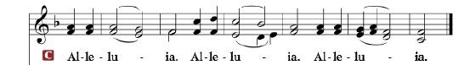

R: The Holy Gospel according to St. Luke, the 15th chapter.

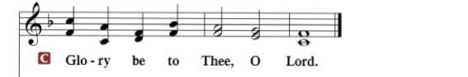

HOLY GOSPEL: (Luke 15:1-10)
Now the tax collectors and sinners were all drawing near to hear him. ² And the Pharisees and the scribes grumbled, saying, “This man receives sinners and eats with them.” ³ So he told them this parable: ⁴ “What man of you, having a hundred sheep, if he has lost one of them, does not leave the ninety-nine in the open country, and go after the one that is lost, until he finds it? ⁵ And when he has found it, he lays it on his shoulders, rejoicing. ⁶ And when he comes home, he calls together his friends and his neighbors, saying to them, ‘Rejoice with me, for I have found my sheep that was lost.’ ⁷ Just so, I tell you, there will be more joy in heaven over one sinner who repents than over ninety-nine righteous persons who need no repentance.
⁸ “Or what woman, having ten silver coins, if she loses one coin, does not light a lamp and sweep the house and seek diligently until she finds it? ⁹ And when she has found it, she calls together her friends and neighbors, saying, ‘Rejoice with me, for I have found the coin that I had lost.’ ¹⁰ Just so, I tell you, there is joy before the angels of God over one sinner who repents.”

R: This is the Gospel of the Lord.

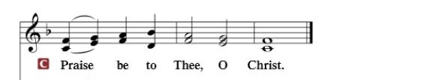

Nicene Creed…...……………………………………………………..…LSB p. 191
I believe in one God, the Father Almighty, maker of heaven and earth and of all things visible and invisible.
And in one Lord Jesus Christ, the only-begotten Son of God, begotten of His Father before all worlds, God of God, Light of Light, very God of very God, begotten, not made, being of one substance with the Father, by whom all things were made; who for us men and for our salvation came down from heaven and was incarnate by the Holy Spirit of the virgin Mary and was made man; and was crucified also for us under Pontius Pilate. He suffered and was buried. And the third day He rose again according to the Scriptures and ascended into heaven and sits at the right hand of the Father. And He will come again with glory to judge both the living and the dead, whose kingdom will have no end.
And I believe in the Holy Spirit, the Lord and giver of life, who proceeds from the Father and the Son, who with the Father and the Son together is worshiped and glorified, who spoke by the prophets. And I believe in one holy Christian and apostolic Church, I acknowledge one Baptism for the remission of sins, and I look for the resurrection of the dead and the life of the world to come. Amen.

SERMON HYMN: “Jesus Sinners Doth Receive”………......................LSB #609

SERMON

OFFERTORY…………………………………………………………...LSB pp. 192-193

GENERAL PRAYERS OF THE CHURCH

Sharing the Peace of the Lord

SERVICE OF THE SACRAMENT
Preface…………………………………….…………….……….LSB p. 194
Proper Preface
It is truly good, right, and salutary that we should at all times and in all places give thanks to You, holy Lord, almighty Father, everlasting God, through Jesus Christ, our Lord, who, out of love for His fallen creation, humbled Himself by taking on the form of a servant, becoming obedient unto death, even death upon a cross. Risen from the dead, He has freed us from eternal death and given us life everlasting. Therefore, with angels and archangels and with all the company of heaven we laud and magnify Your glorious name, ever more praising You and saying:

Sanctus, Lord’s Prayer, The Words of Our Lord………………….....LSB pp. 195-197
Agnus Dei………………………………………………………………..LSB p. 198
If you are not communing, it is acceptable to remain seated.

COMMUNION DISTRIBUTION HYMNS:
LSB #682 “God of the Prophets, Bless the Prophets’ Sons”
LSB #554 “O Jesus, King Most Wonderful”
LSB #742 “For Me to Live is Jesus”

NUNC DIMITTIS………………………………………………………LSB pp. 199-200

BENEDICTION

CLOSING HYMN: “Amazing Grace”....................................................LSB #744

The Mission of Trinity Onekama Is To SERVE

For even the Son of Man did not come to be served
but to serve and to give his life as a ransom for many.
Mark 10:45

S haring Jesus’s truth
E quipping for life
R eaching Out
V aluing each other
E vangelizing all ages
Mission Statement
The mission of Trinity Onekama is to SERVE
For even the Son of Man did not come to be served, but to serve,
and to give his life as a ransom for many. Mark 10:45
S haring Jesus’ ruth
E quipping for life
R eaching Out
V aluing each other
E vangelizing all age

CHURCH INFORMATION
Church Office: (231) 889-4429 Website: www.trinityonekama.org
E-mail: trinityonekama@sbcglobal.net
Address: P.O. Box 119, 5471 Fairview Street, Onekama, MI 49675
Adult Bible Study: Sunday @ 11:30 am (year round)
Worship: Sunday @ 10:30 am The Lord’s Supper: Celebrated 2nd & 4th Sundays
Pastoral Hours: Wednesday and Friday 9:00am – Noon
Pastor Phone: 231-655-2680 Pastor Email: trinityonekama@gmail.com

Copyright licensing covered under CCLI #2802932

