231-889-4429 5471 Fairview Street, Box 119 Onekama, MI

TRINITY LUTHERAN CHURCH
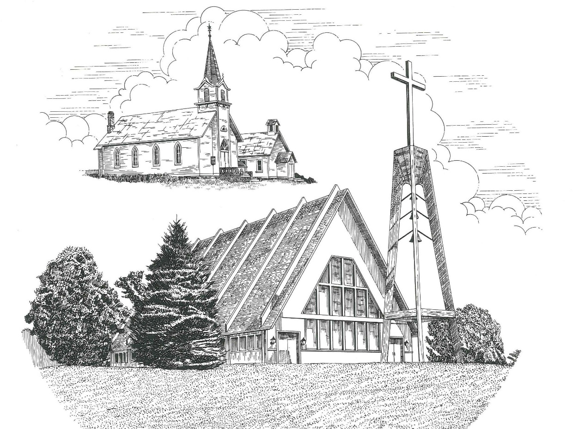

Sixteenth Sunday after Pentecost September 12th, 2021

WELCOME
Thanks for joining us!
Pastor Jacob Sherry Missouri Synod

~~PLEASE NOTE~~
Calling on the name of the Lord
Does not include the use of cell phones in the worship sanctuary.
Please check yours before the service begins. Thank you for your courtesy.
~~TO OUR GUESTS AND VISITORS~~
Please sign our guest book located on the stand at the church entrance. During the service, we ask you to sign the attendance booklet located at the end of each pew. If you need assistance or have questions about our worship service, please talk to an elder or any one of our church family. We are glad you could join us and hope to have you worship with us again soon.

~~ATTENDING HOLY COMMUNION~~
By checking the “Communing Today” box on the registration form found in the attendance booklet, you are agreeing with the following statements:

- I am a baptized Christian who believes Jesus Christ is my Lord and Savior.
- I believe that I am a sinner in need of Christ freely offered forgiveness.
- I believe that in the Lord’s Supper the body and blood of Jesus Christ
are truly present in, with, and under the bread and wine.
- I believe that my participation in Holy Communion grants me forgiveness
of my sins, new spiritual life, and eternal salvation.
- With God’s help, I sincerely seek to repent of my sins, live in service
to my Lord, and await His return.

If you agree with the above statements, you are welcome to attend the Lord’s Supper with us. May God bless your worship time with us.
We do offer gluten-free wafers, please quietly ask an elder to help you.

Order of Divine Service Setting Three

Pre-Service Music……………..Call to Worship………………….Greeting

OPENING HYMN: “Oh, for a Thousand Tongues to Sing”...................LSB #528

OPENING LITURGY:
Confession & Absolution………..………………………………LSB pp. 184-185
Kyrie…………………………………….………………………..LSB p. 186
Gloria in Excelsis……...…………………………………………LSB pp. 187-188
Salutation….……………………………….…………………….LSB p. 189

Collect Prayer
Lord Jesus Christ, our support and defense in every need, continue to preserve Your Church in safety, govern her by Your goodness, and bless her with Your peace: for You lives and reigns with the Father and the Holy Spirit, one God, now and forever.

Baptismal Hymn: “Dearest Jesus, We Are Here”……………………....LSB #592
Verses 1-3

THE BAPTISMS OF DARRELL JAMES EBELING..…….………..LSB pp. 268-271
AND RILEY RAE RINGEL

Baptismal Hymn: “Dearest Jesus, We Are Here”……………………....LSB #592
Verses 4-5

THE HOLY SCRIPTURES

OLD TESTAMENT: (Isaiah 50:4-10)
⁴ The Lord God has given me
the tongue of those who are taught,
that I may know how to sustain with a word
him who is weary.
Morning by morning he awakens;
he awakens my ear
to hear as those who are taught.
⁵ The Lord God has opened my ear,
and I was not rebellious;
I turned not backward.
⁶ I gave my back to those who strike,
and my cheeks to those who pull out the beard;
I hid not my face
from disgrace and spitting.
⁷ But the Lord God helps me;
therefore I have not been disgraced;
therefore I have set my face like a flint,
and I know that I shall not be put to shame.
⁸ He who vindicates me is near.
Who will contend with me?
Let us stand up together.
Who is my adversary?
Let him come near to me.
⁹ Behold, the Lord God helps me;
who will declare me guilty?
Behold, all of them will wear out like a garment;
the moth will eat them up.
¹⁰ Who among you fears the Lord
and obeys the voice of his servant?
Let him who walks in darkness
and has no light
trust in the name of the Lord
and rely on his God.

R: This is the Word of the Lord. Cong: Thanks be to God.

GRADUAL
Reader: Fear the Lord, you his saints,
Cong.: for those who fear him lack nothing!
Reader: Many are the afflictions of the righteous,
Cong.: but the Lord delivers him out of them all.

EPISTLE: (James 3:1-12)
Not many of you should become teachers, my brothers, for you know that we who teach will be judged with greater strictness. ² For we all stumble in many ways. And if anyone does not stumble in what he says, he is a perfect man, able also to bridle his whole body. ³ If we put bits into the mouths of horses so that they obey us, we guide their whole bodies as well. ⁴ Look at the ships also: though they are so large and are driven by strong winds, they are guided by a very small rudder wherever the will of the pilot directs. ⁵ So also the tongue is a small member, yet it boasts of great things.
How great a forest is set ablaze by such a small fire! ⁶ And the tongue is a fire, a world of unrighteousness. The tongue is set among our members, staining the whole body, setting on fire the entire course of life, and set on fire by hell. ⁷ For every kind of beast and bird, of reptile and sea creature, can be tamed and has been tamed by mankind, ⁸ but no human being can tame the tongue. It is a restless evil, full of deadly poison. ⁹ With it we bless our Lord and Father, and with it we curse people who are made in the likeness of God. ¹⁰ From the same mouth come blessing and cursing. My brothers, these things ought not to be so. ¹¹ Does a spring pour forth from the same opening both fresh and salt water? ¹² Can a fig tree, my brothers, bear olives, or a grapevine produce figs? Neither can a salt pond yield fresh water.

R: This is the Word of the Lord. Cong: Thanks be to God.

(PLEASE RISE for the reading of the Gospel)

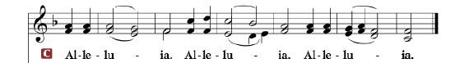

R: The Holy Gospel according to St. Mark, the 9th chapter.

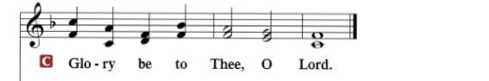

HOLY GOSPEL: (Mark 9:14-29)
¹⁴ And when they came to the disciples, they saw a great crowd around them, and scribes arguing with them. ¹⁵ And immediately all the crowd, when they saw him, were greatly amazed and ran up to him and greeted him. ¹⁶ And Jesus asked them, “What are you arguing about with them?” ¹⁷ And someone from the crowd answered him, “Teacher, I brought my son to you, for he has a spirit that makes him mute. ¹⁸ And whenever it seizes him, it throws him down, and he foams and grinds his teeth and becomes rigid. So I asked your disciples to cast it out, and they were not able.” ¹⁹ And he answered them, “O faithless generation, how long am I to be with you? How long am I to bear with you? Bring him to me.” ²⁰ And they brought the boy to him. And when the spirit saw him, immediately it convulsed the boy, and he fell on the ground and rolled about, foaming at the mouth. ²¹ And Jesus asked his father, “How long has this been happening to him?” And he said, “From childhood. ²² And it has often cast him into fire and into water, to destroy him. But if you can do anything, have compassion on us and help us.” ²³ And Jesus said to him, “‘If you can’! All things are possible for one who believes.” ²⁴Immediately the father of the child cried out and said, “I believe; help my unbelief!” ²⁵ And when Jesus saw that a crowd came running together, he rebuked the unclean spirit, saying to it, “You mute and deaf spirit, I command you, come out of him and never enter him again.” ²⁶ And after crying out and convulsing him terribly, it came out, and the boy was like a corpse, so that most of them said, “He is dead.” ²⁷ But Jesus took him by the hand and lifted him up, and he arose. ²⁸ And when he had entered the house, his disciples asked him privately, “Why could we not cast it out?” ²⁹ And he said to them, “This kind cannot be driven out by anything but prayer.”

R: This is the Gospel of the Lord.

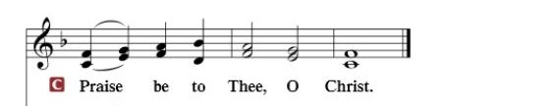

Nicene Creed
I believe in one God, the Father Almighty, maker of heaven and earth and of all things visible and invisible.
And in one Lord Jesus Christ, the only-begotten Son of God, begotten of His Father before all worlds, God of God, Light of Light, very God of very God, begotten, not made, being of one substance with the Father, by whom all things were made; who for us men and for our salvation came down from heaven and was incarnate by the Holy Spirit of the virgin Mary and was made man; and was crucified also for us under Pontius Pilate. He suffered and was buried. And the third day He rose again according to the Scriptures and ascended into heaven and sits at the right hand of the Father. And He will come again with glory to judge both the living and the dead, whose kingdom will have no end.
And I believe in the Holy Spirit, the Lord and giver of life, who proceeds from the Father and the Son, who with the Father and the Son together is worshiped and glorified, who spoke by the prophets. And I believe in one holy Christian and apostolic Church, I acknowledge one Baptism for the remission of sins, and I look for the resurrection of the dead and the life of the world to come. Amen.

SERMON HYMN: “Thee Will I Love, My Strength, My Tower”...........LSB #694

SERMON

OFFERTORY……………………………………………………..……LSB pp. 192-193

THE GENERAL PRAYERS OF THE CHURCH

INSTITUTION OF THE LORD’S SUPPER
Preface…………………………………….…………….……….LSB p. 194

Proper Preface
It is truly good, right, and salutary that we should at all times and in all places give thanks to You, holy Lord, almighty Father, everlasting God, through Jesus Christ, our Lord, who, out of love for His fallen creation, humbled Himself by taking on the form of a servant, becoming obedient unto death, even death upon a cross. Risen from the dead, He has freed us from eternal death and given us life everlasting. Therefore, with angels and archangels and with all the company of heaven we laud and magnify Your glorious name, ever more praising You and saying:

Sanctus, Lord’s Prayer, The Words of Our Lord………………….....LSB pp. 195-197
Agnus Dei………………………………………………………………..LSB p. 198
If you are not communing it is acceptable to remain seated.

COMMUNION DISTRIBUTION HYMNS:
LSB #740 “I Am Jesus’ Little Lamb”
LSB #578 “Thy Strong Word”

NUNC DIMITTIS………………………………………………………LSB pp. 199-200

BENEDICTION

CLOSING HYMN: “What a Friend We Have in Jesus”........................LSB #770

CHURCH INFORMATION
Church Office: (231) 889-4429 Website: www.trinityonekama.org
E-mail: trinityonekama@sbcglobal.net
Address: P.O. Box 119, 5471 Fairview Street, Onekama, MI 49675
Adult Bible Study: Sunday @ 9:15 am (year round)
Worship: Sunday @ 10:30 am The Lord’s Supper: Celebrated 2nd & 4th Sundays
Pastoral Hours: Wednesday and Friday 8:30am – Noon
Pastor Phone: 231-655-2680 Pastor Email: trinityonekama@gmail.com

Copyright licensing covered under CCLI #2802932

