**231-889-4429 5471 Fairview Street, Box 119 Onekama, MI**

**TRINITY LUTHERAN CHURCH**

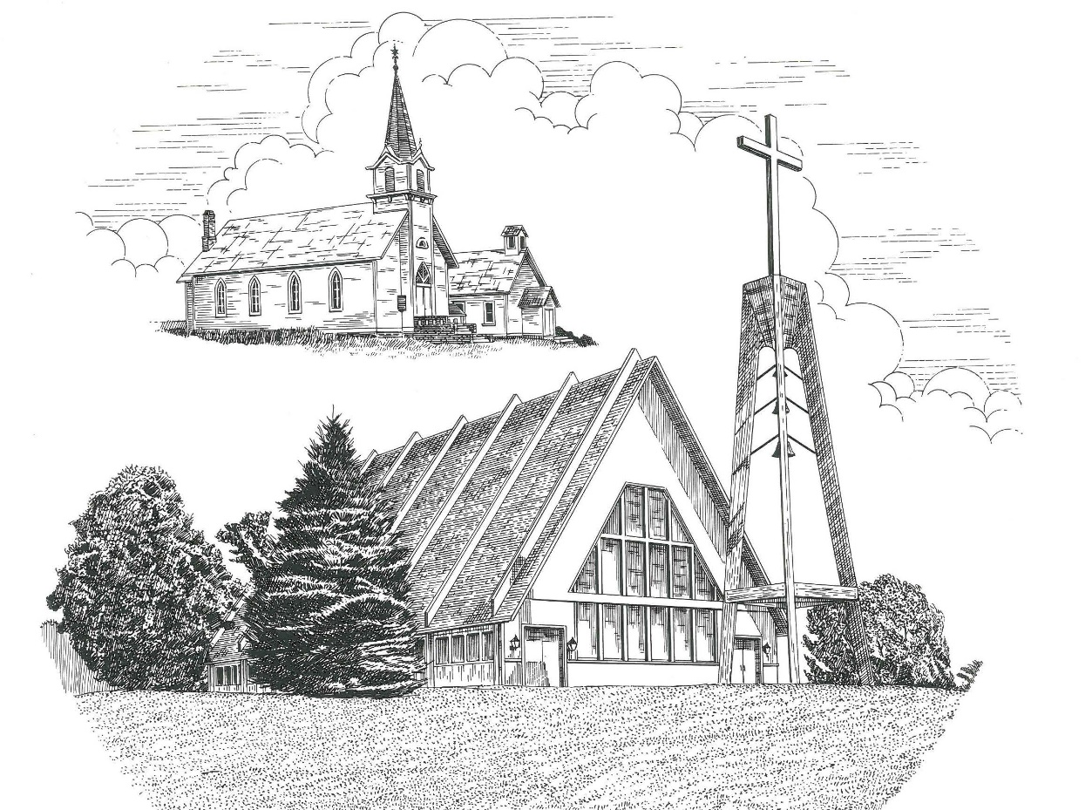

**Eighteenth Sunday after Pentecost September 26th, 2021**

**WELCOME**

**Thanks for joining us!**

**Pastor Jacob Sherry Missouri Synod**

**~~PLEASE NOTE~~Calling on the name of the Lord**

Does not include the use of cell phones in the worship sanctuary.

Please check yours before the service begins. Thank you for your courtesy.

**~~TO OUR GUESTS AND VISITORS~~**

Please sign our guest book located on the stand at the church entrance. During the service, we ask you to sign the attendance booklet located at the end of each pew. If you need assistance or have questions about our worship service, please talk to an elder or any one of our church family. We are glad you could join us and hope to have you worship with us again soon.

**~~ATTENDING HOLY COMMUNION~~**

By checking the “Communing Today” box on the registration form found in the attendance booklet, you are agreeing with the following statements:

* **I am a baptized Christian who believes Jesus Christ is my Lord and Savior.**
* **I believe that I am a sinner in need of Christ freely offered forgiveness.**
* **I believe that in the Lord’s Supper the body and blood of Jesus Christ**

**are truly present in, with, and under the bread and wine.**

* **I believe that my participation in Holy Communion grants me forgiveness**

**of my sins, new spiritual life, and eternal salvation.**

* **With God’s help, I sincerely seek to repent of my sins, live in service**

**to my Lord, and await His return.**

**If you agree with the above statements, you are welcome to attend the Lord’s Supper with us. May God bless your worship time with us.**

We do offer gluten-free wafers, please quietly ask an elder to help you.

**Order of Divine Service Setting One**

**Pre-Service Music……………..Call to Worship………………….Greeting**

**OPENING HYMN:** *“Praise to the Lord, the Almighty”*……………….LSB #790

**CONFESSION & ABSOLUTION**……………………………………..LSB p. 151

**KYRIE**…………………………………………………………………...LSB pp. 152-153

**THIS IS THE FEAST**…………………………………………………..LSB p. 155

**SALUTATION**………………………………………………………….LSB p. 156

**Collect Prayer**

Everlasting Father, source of every blessing, mercifully direct and govern us by Your Holy Spirit that we may complete the works You have prepared for us to do; through Jesus Christ, Your Son, our Lord, who lives and reign with You and the Holy Spirit, one God, now and forever.

**THE HOLY SCRIPTURES**

**OLD TESTAMENT:** (Numbers 11:4-6, 10-16, 24-29)

**4**Now the rabble that was among them had a strong craving. And the people of Israel also wept again and said, “Oh that we had meat to eat!  **5**We remember the fish we ate in Egypt that cost nothing, the cucumbers, the melons, the leeks, the onions, and the garlic. **6**But now our strength is dried up, and there is nothing at all but this manna to look at.”

**10**Moses heard the people weeping throughout their clans, everyone at the door of his tent. And the anger of the Lord blazed hotly, and Moses was displeased.  **11**Moses said to the Lord, “Why have you dealt ill with your servant? And why have I not found favor in your sight, that you lay the burden of all this people on me?  **12**Did I conceive all this people? Did I give them birth, that you should say to me, ‘Carry them in your bosom, as a nurse carries a nursing child,’ to the land that you swore to give their fathers?  **13**Where am I to get meat to give to all this people? For they weep before me and say, ‘Give us meat, that we may eat.’  **14**I am not able to carry all this people alone; the burden is too heavy for me.  **15**If you will treat me like this, kill me at once, if I find favor in your sight, that I may not see my wretchedness.”

**16**Then the Lord said to Moses, “Gather for me seventy men of the elders of Israel, whom you know to be the elders of the people and officers over them, and bring them to the tent of meeting, and let them take their stand there with you.

**24**So Moses went out and told the people the words of the Lord.  And he gathered seventy men of the elders of the people and placed them around the tent. **25**Then the Lord came down in the cloud and spoke to him, and took some of the Spirit that was on him and put it on the seventy elders. And as soon as the Spirit rested on them, they prophesied. But they did not continue doing it.

**26**Now two men remained in the camp, one named Eldad, and the other named Medad, and the Spirit rested on them. They were among those registered, but they had not gone out to the tent, and so they prophesied in the camp.  **27**And a young man ran and told Moses, “Eldad and Medad are prophesying in the camp.”  **28**And Joshua the son of Nun, the assistant of Moses from his youth, said, “My lord Moses, stop them.”  **29**But Moses said to him, “Are you jealous for my sake?  Would that all the Lord's people were prophets, that the Lord would put his Spirit on them!”

**R:** This is the Word of the Lord**.** **Cong: Thanks be to God.**

**GRADUAL**

Reader: He will command his angels concerning you

**Cong.: to guard you in all your ways.**

Reader: Bless the Lord, O my soul,

**Cong.: and all that is within me, bless his holy name!**

**EPISTLE:** (James 5:13-20)

**13**Is anyone among you suffering? Let him pray. Is anyone cheerful? Let him sing praise.  **14**Is anyone among you sick? Let him call for the elders of the church, and let them pray over him, anointing him with oil in the name of the Lord.  **15**And the prayer of faith will save the one who is sick, and the Lord will raise him up. And if he has committed sins, he will be forgiven.  **16**Therefore, confess your sins to one another and pray for one another, that you may be healed.  The prayer of a righteous person has great power as it is working.  **17**Elijah was a man with a nature like ours, and he prayed fervently that it might not rain, and for three years and six months it did not rain on the earth.  **18**Then he prayed again, and heaven gave rain, and the earth bore its fruit. **19**My brothers, if anyone among you wanders from the truth and someone brings him back, **20**let him know that whoever brings back a sinner from his wandering will save his soul from death and will cover a multitude of sins.

**R:** This is the Word of the Lord. **Cong: Thanks be to God.**

**(PLEASE RISE for the reading of the Gospel)**



**R:** The Holy Gospel according to St. Mark, the 9th chapter.



**HOLY GOSPEL:** (Mark 9:38-50)

**38**John said to him, “Teacher, we saw someone casting out demons in your name, and we tried to stop him, because he was not following us.”  **39**But Jesus said, “Do not stop him, for no one who does a mighty work in my name will be able soon afterward to speak evil of me.  **40**For the one who is not against us is for us.  **41**For truly, I say to you, whoever gives you a cup of water to drink because you belong to Christ will by no means lose his reward. **42**“Whoever causes one of these little ones who believe in me to sin, it would be better for him if a great millstone were hung around his neck and he were thrown into the sea.  **43**And if your hand causes you to sin, cut it off. It is better for you to enter life crippled than with two hands to go to hell, to the unquenchable fire.  **45**And if your foot causes you to sin, cut it off. It is better for you to enter life lame than with two feet to be thrown into hell.  **47**And if your eye causes you to sin, tear it out. It is better for you to enter the kingdom of God with one eye than with two eyes to be thrown into hell, **48’**where their worm does not die and the fire is not quenched.’  **49**For everyone will be salted with fire.  **50**Salt is good, but if the salt has lost its saltiness, how will you make it salty again?  Have salt in yourselves, and be at peace with one another.”

**R:** This is the Gospel of the Lord.



**SERMON HYMN**: *“Chief of Sinners Though I Be”*…………………………...LSB #611

**SERMON**

**NICENE CREED**

I believe in one God, the Father Almighty, maker of heaven and earth and of all things visible and invisible.

And in one Lord Jesus Christ, the only-begotten Son of God, begotten of His Father before all worlds, God of God, Light of Light, very God of very God, begotten, not made, being of one substance with the Father, by whom all things were made; who for us men and for our salvation came down from heaven and was incarnate by the Holy Spirit of the virgin Mary and was made man; and was crucified also for us under Pontius Pilate. He suffered and was buried. And the third day He rose again according to the Scriptures and ascended into heaven and sits at the right hand of the Father. And He will come again with glory to judge both the living and the dead, whose kingdom will have no end.

And I believe in the Holy Spirit, the Lord and giver of life, who proceeds from the Father and the Son, who with the Father and the Son together is worshiped and glorified, who spoke by the prophets. And I believe in one holy Christian and apostolic Church, I acknowledge one Baptism for the remission of sins, and I look for the resurrection of the dead and the life of the world to come. Amen.

**THE GENERAL PRAYERS OF THE CHURCH**

**OFFERTORY**…………………………………………………………...LSB pp. 159-160

**SERVICE OF THE SACRAMENT**

**PREFACE**……………………………………………………………………..LSB p. 160

**Proper Preface**

It is truly good, right, and salutary that we should at all times and in all places give thanks to You, holy Lord, almighty Father, everlasting God, through Jesus Christ, our Lord, who, out of love for His fallen creation, humbled Himself by taking on the form of a servant, becoming obedient unto death, even death upon a cross. Risen from the dead, He has freed us from eternal death and given us life everlasting. Therefore, with angels and archangels and with all the company of heaven we laud and magnify Your glorious name, ever more praising You and saying:

**SANCTUS**……………………………………………………………………...LSB p. 161

**THE WORDS OF OUR LORD**……………………………………………….LSB p. 162

**AGNUS DEI**……………………………………………………………………LSB p. 163

*If you are not communing it is acceptable to remain seated.*

**COMMUNION DISTRIBUTION HYMNS**

LSB #537 *“Beautiful Savior”*

LSB #673 *“Jerusalem, My Happy Home”*

**THANK THE LORD**………………………………………………………….LSB p. 164

**POST-COMMUNION COLLECT PRAYER**……………………………….LSB p. 166

**BENEDICTION**……………………………………………………………….LSB p. 166

**CLOSING HYMN:** *“God of Grace and God of Glory”*……..………………..LSB #850

The Mission of Trinity Onekama Is To **SERVE**

For even the Son of Man did not come to be served

but to serve and to give his life as a ransom for many.            
                                                                       Mark 10:45



**S**haring Jesus’s **t**ruth

**E**quipping for life

**R**eaching Out

**V**aluing each other

**E**vangelizing all ages

Mission Statement

The mission of Trinity Onekama is to SERVE

For even the Son of Man did not come to be served, but to serve,

and to give his life as a ransom for many. Mark 10:45

S haring Jesus’ ruth

E quipping for life

R eaching Out

V aluing each other

E vangelizing all age

**CHURCH INFORMATION**

**Church Office:** (231) 889-4429 **Website:** www.trinityonekama.org

**E-mail:** [trinityonekama@sbcglobal.net](mailto:trinityonekama@sbcglobal.net)

**Address:** P.O. Box 119, 5471 Fairview Street, Onekama, MI 49675

**Adult Bible Study**: Sunday @ 9:15 am (year round)

**Worship:** Sunday @ 10:30 am **The Lord’s Supper:**  Celebrated 2nd & 4th Sundays

**Pastoral Hours:** Wednesday and Friday 8:30am – Noon

**Pastor Phone:** 231-655-2680 **Pastor Email:** trinityonekama@gmail.com

**Copyright licensing covered under CCLI #2802932**